GIT HUB

1. Introduction to Git Hub

**Github** is a web-based platform used for version control. Git simplifies the process of working with other people and makes it easy to collaborate on projects. Team members can work on files and easily merge their changes in with the master branch of the project.

1. Create Git Hub Account

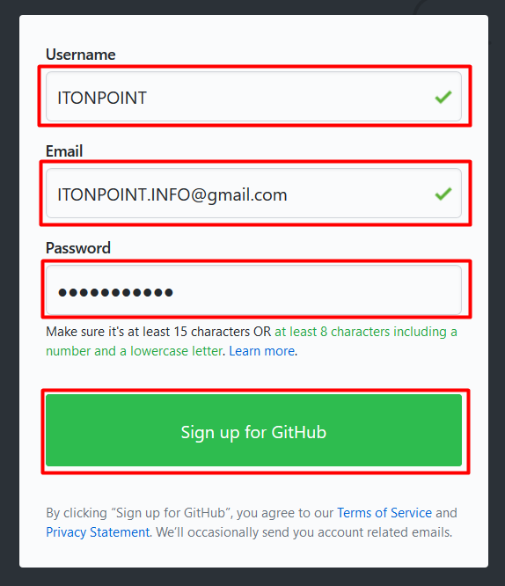Go to <https://github.com/>

You must fill **Username**, **Email**, and

**Password**, then click **Sign Up** **for**

**GitHub**.

Click Verify and complete the puzzle, then

Click Done.

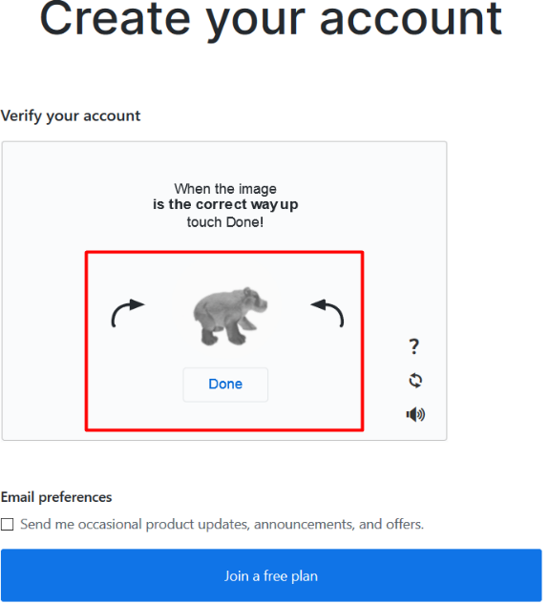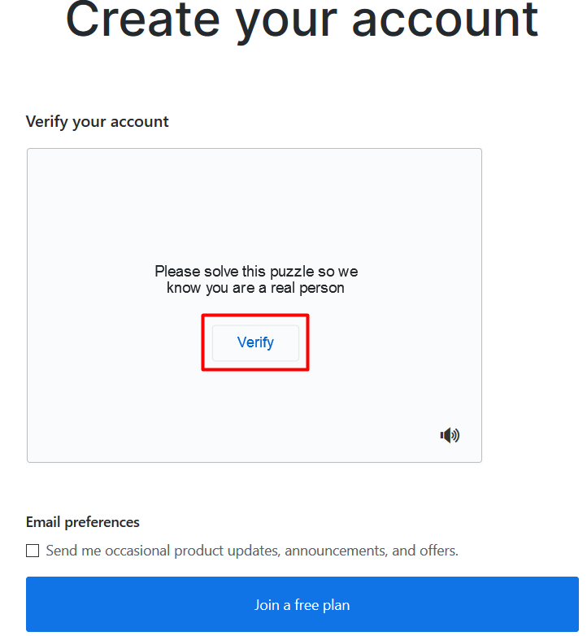

Click **Join a free plan** and Click **Choose Free**.

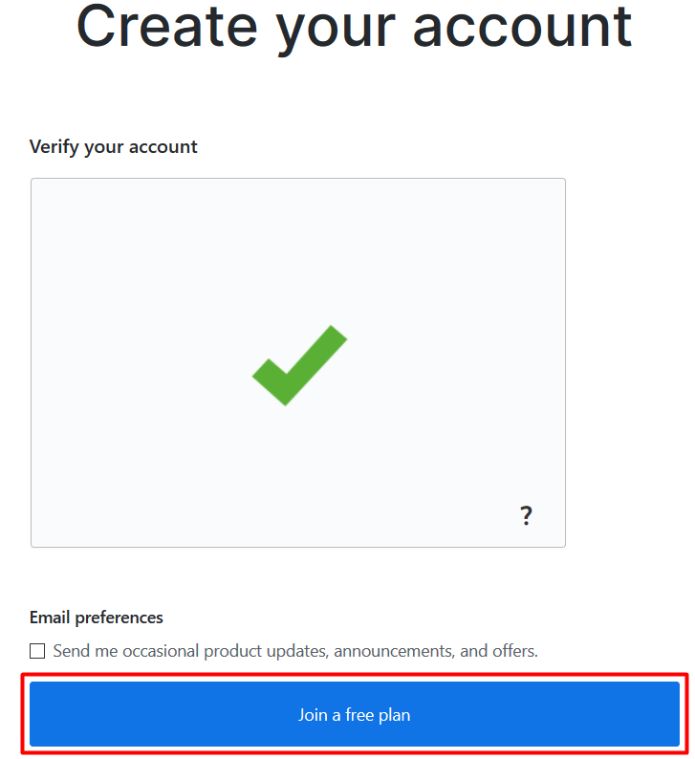

In this to fill optional information, so I don’t want to fill it now.

Click **Skip this step**.

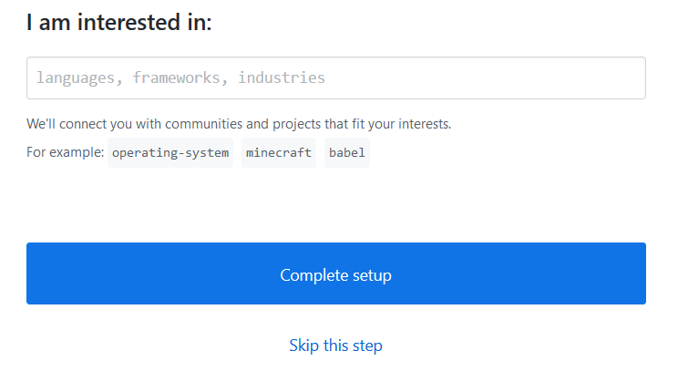

In this step GitHub verify account with your **email account**.

You need to go your email account and open it.

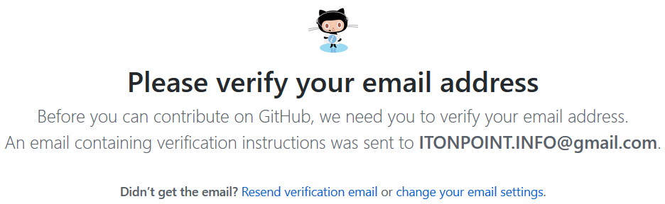

As you see as below, then click **Verify email address**.

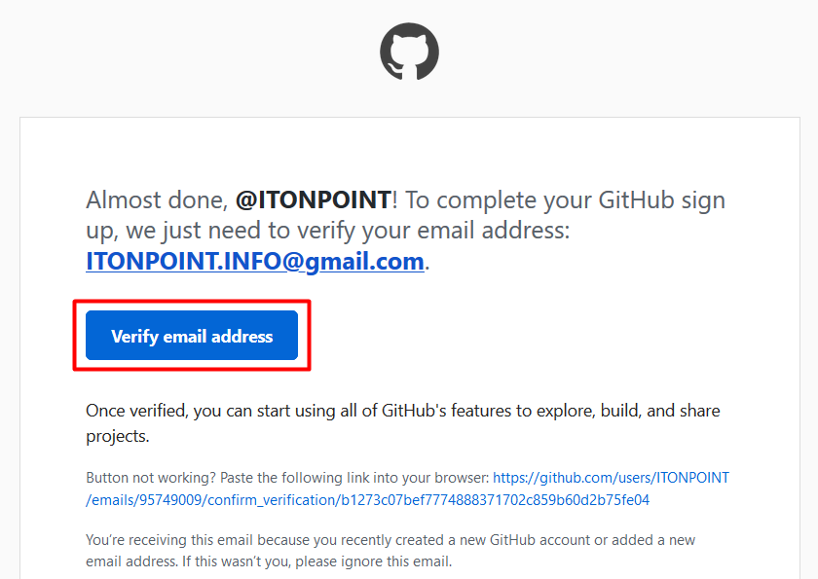

You need fill your **Repository name**, Description.

Tick 🗹 Initialize this repository with a README: to create a readme.md file.

Click **Create Repository**.

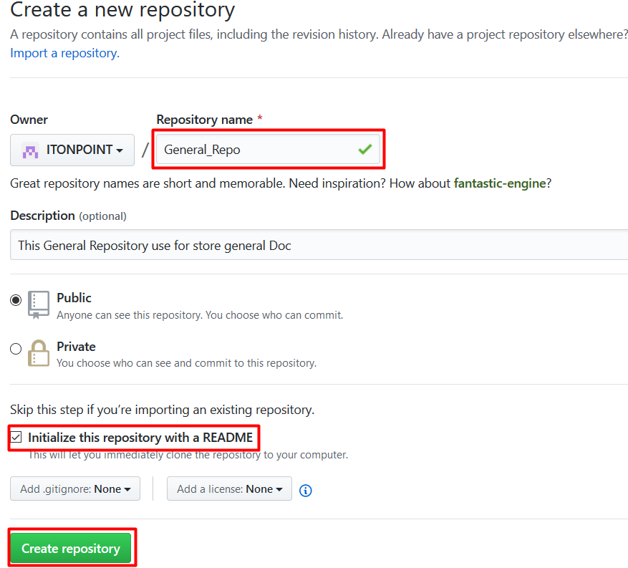

Here it is our repository name: General_Repo

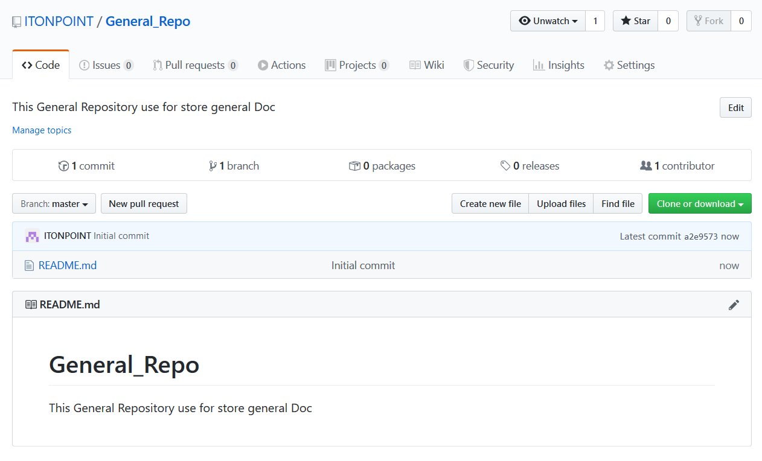

1. Installation GitHub Desktop and Cloning from Internet

Go to <https://desktop.github.com/>

Click **Download for windows** and **install GitHub Desktop**

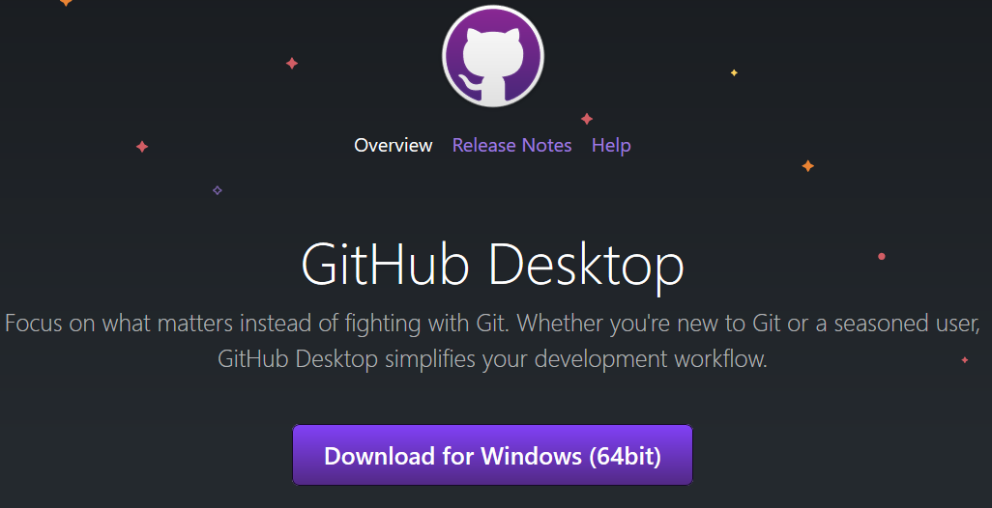

After install GitHub Desktop, open GitHub Desktop and click Clone a repository from the internet.

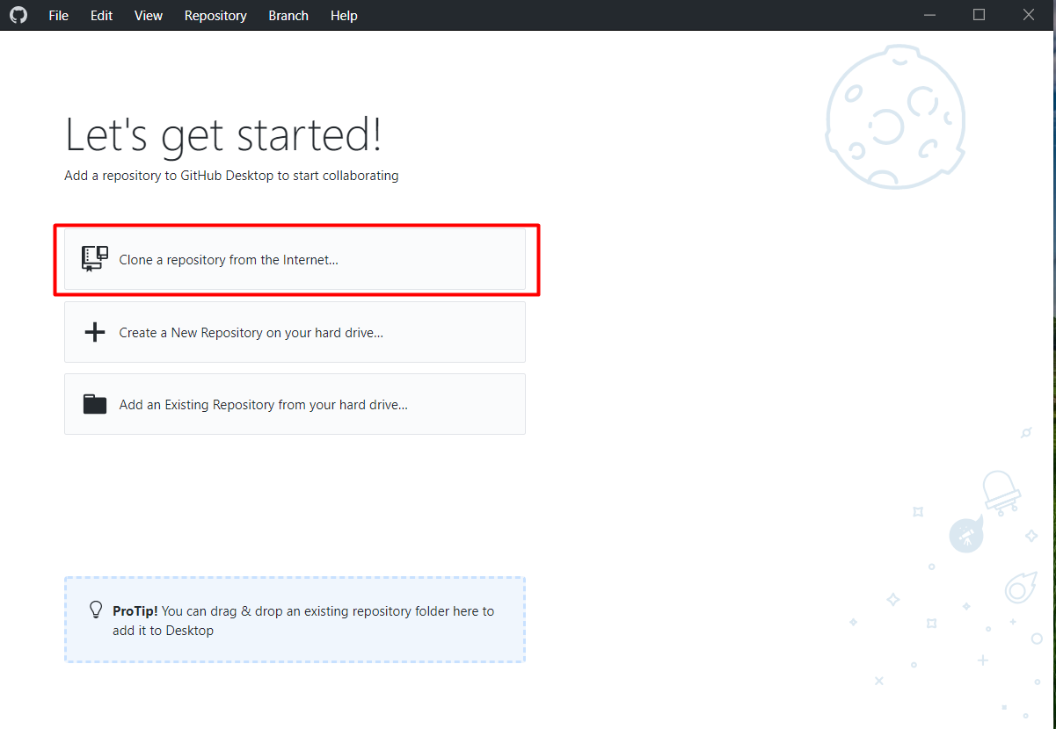

Click Sign in.

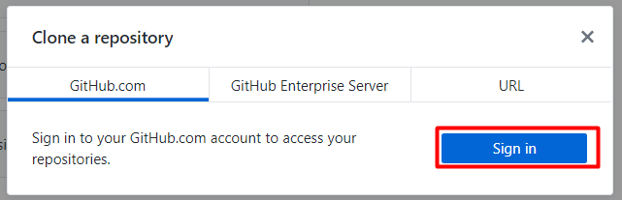

Fill GitHub account: **Username** and **Password**, then Click **Sign in**.

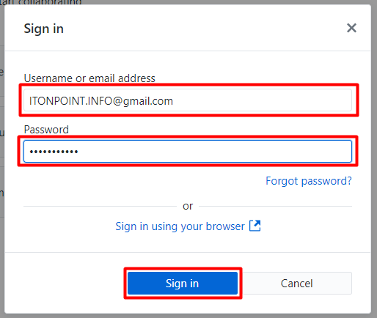

Click on Your repositories then click Clone.

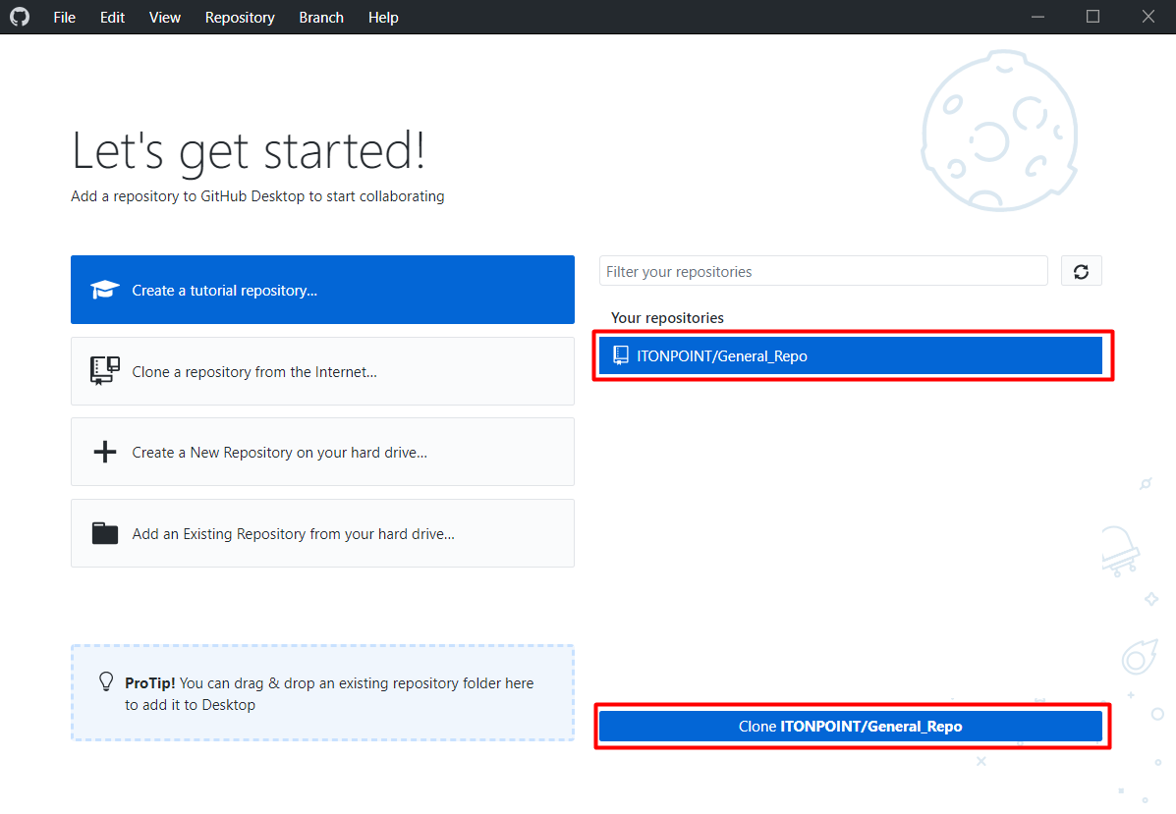

For my local computer, I created folder **GitHub_store** on Drive ( D: )

**General_Repo**: is a folder generate by GitHub

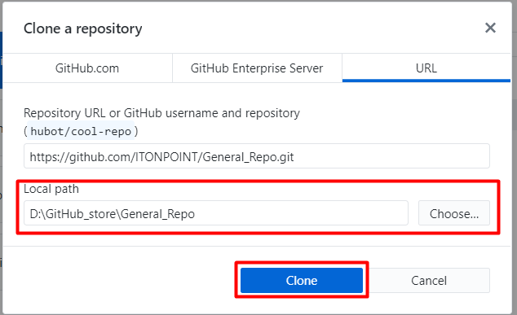

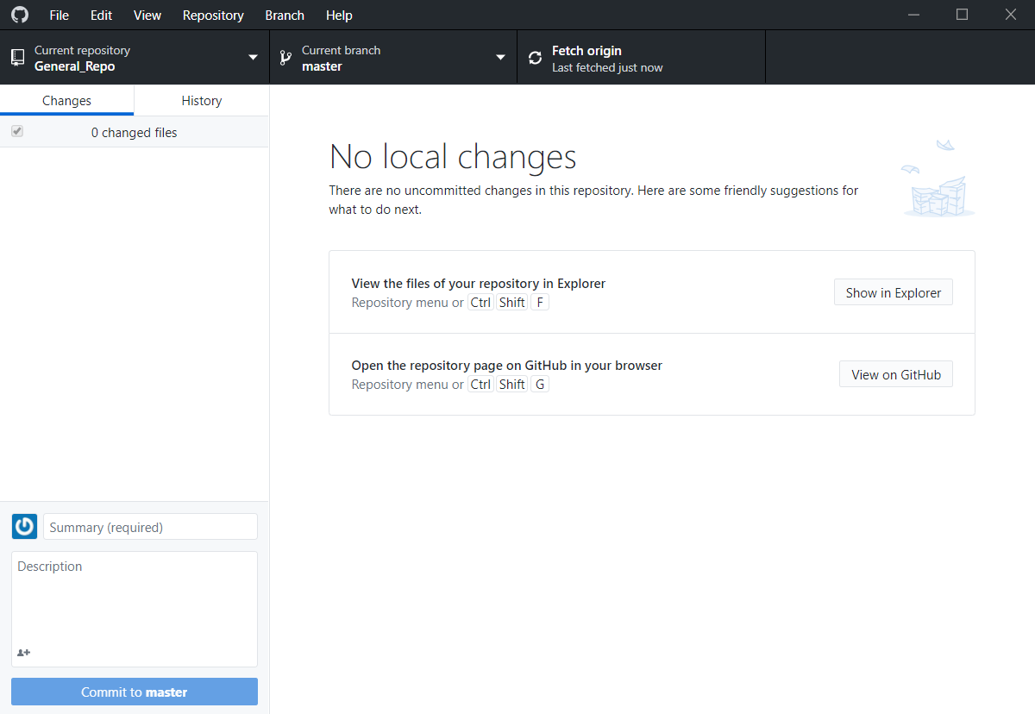

1. Installation Git (Git bash)

Go to <https://git-scm.com/download/win>

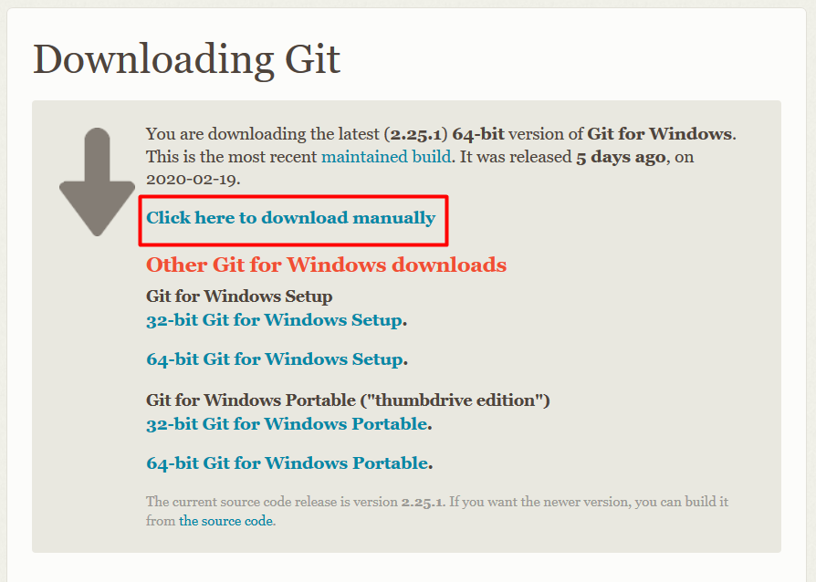

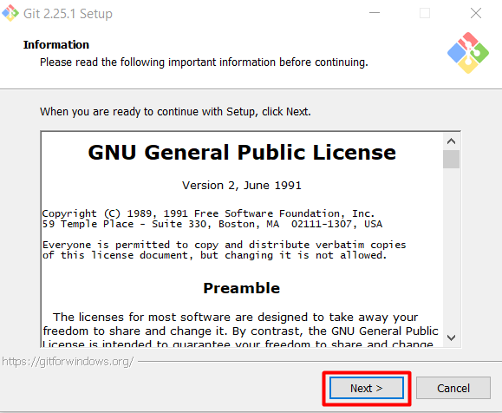

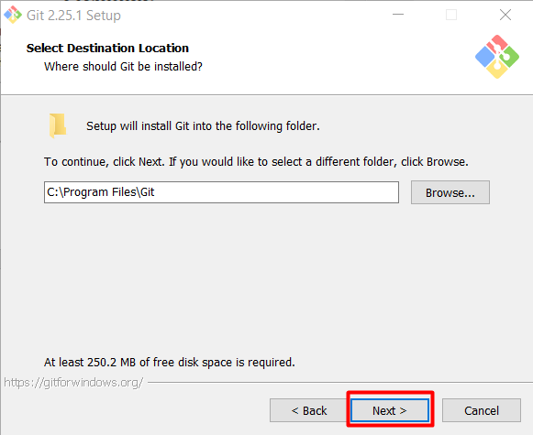

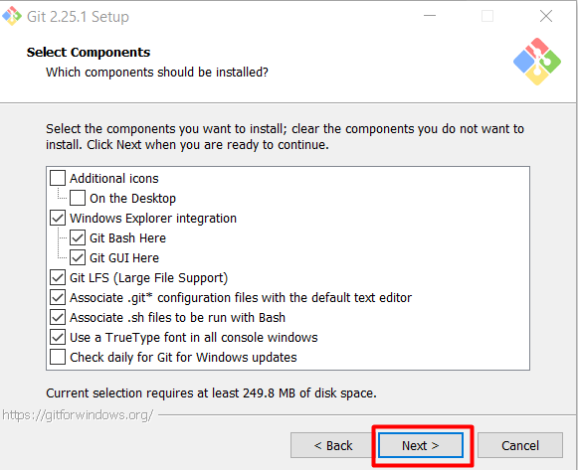

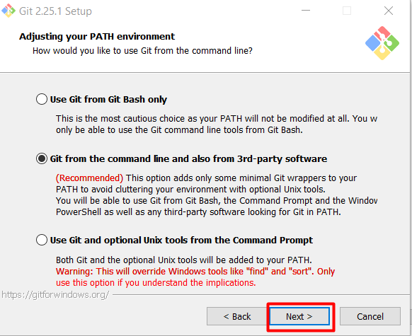

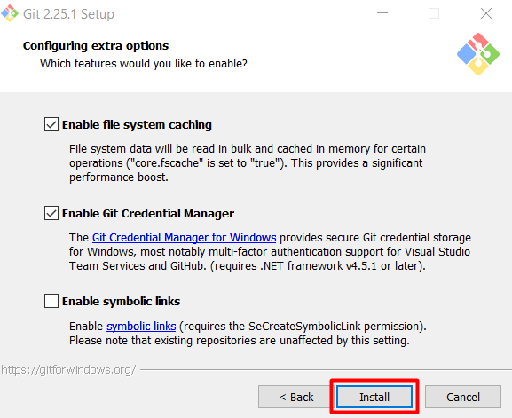

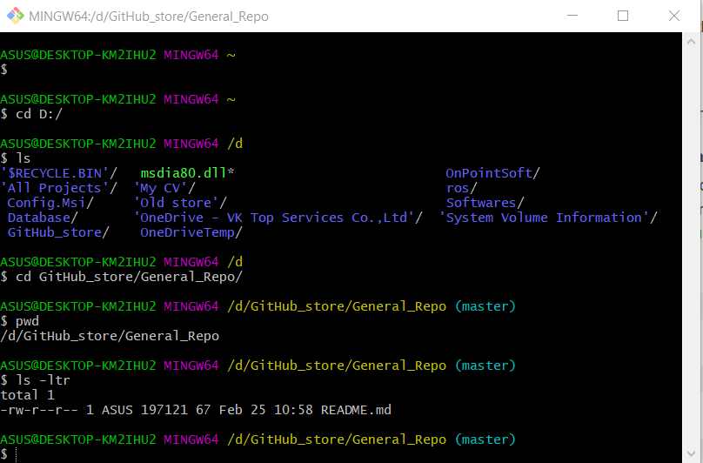

1. Some command on Git Bash

**git init [repository name]:** is used to start a new repository.

**git clone [url]:** is used to clone exist repository from url (internet)

**git add [file name]:** is used to push file to Git server

git commit -m "Add some message": is use records or snapshots the file permanently in the version history.

**git status:** lists all the files that have to be committed.

**git diff:** shows the file differences which are not yet staged.

**git diff -staged:** shows the differences between the files in the staging area and the latest version present.

**git diff [first_brn] [second_brn]:** shows the differences between the two branches mentioned.

**git branch:** is used to all branches.

**git checkout [branch name]:** is used to switch branch

**git checkout -b [branch name]** is used to create new brn and switch to it.

**git push [variable name] master:** sends the committed changes of master branch to your remote repository.

**git push origin master**

**git pull [repository link]:** fetches and merges changes on the remote server to your working directory.

1. Example with Git Bash

In this example, I will create new branch call **Tutorial** and create a file call **toturial.txt** and add some text, then push that to Github web-based.

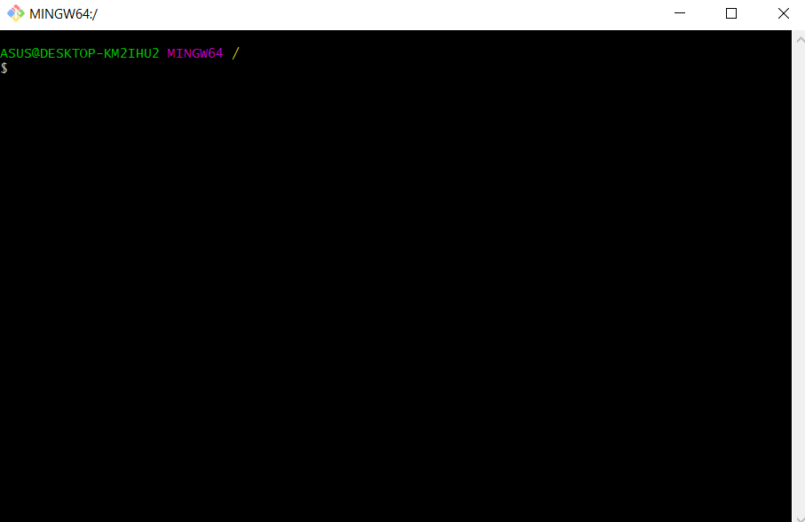First, open Git bash

Type command as below:

Go to directory on your local machine (This directory is cloned from GitHub web-based using GitHub Desktop)

cd d:/GitHub_store/General_Repo

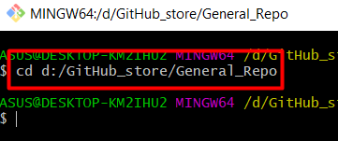

To initialize github

git init

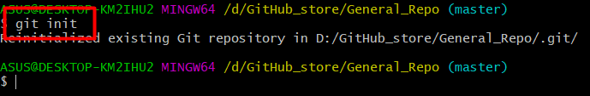

To update your master branch.

git pull

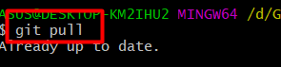

To Create new branch call Tutorial by clone from master branch.

But it just create new branch on your local machine.

git checkout -b Tutorial or git branch Tutorial

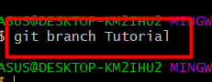

To push your new branch to server

git push origin Tutorial

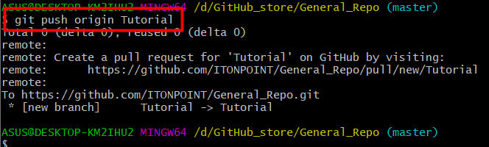

To check your new branch

git branch

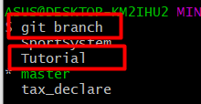

To switch from master branch to Tutorial branch, because we need to work on Tutorial branch

git checkout Tutorial

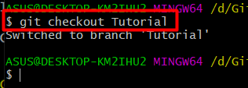

To check your current branch

Git status

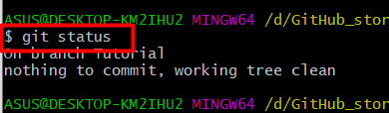

Create a file, I just create new text file name tutorial.txt

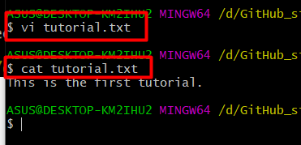

Add **tutorial.txt** to Tutorial branch

Git add tutorial.txt

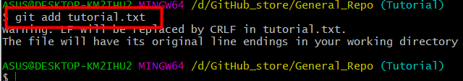

To commit tutorial.txt file with some message.

Git commit -m “Add tutorial.txt”

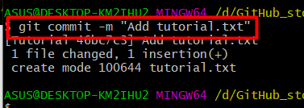

To push file has been added to branch Tutorial on server

Git push origin Tutorial

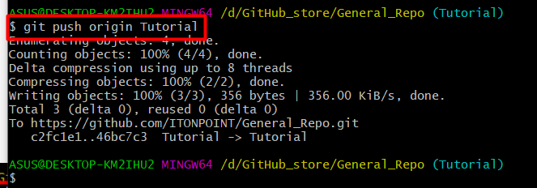

For merge file from Tutorial branch to master branch, they recommended to use GitHub web.

